Glowtag — High-Level Design v. 0.1
The carried object is the Data Crown, "the Crown" in shorthand.

Concept
One Crown in a closed arena. Whoever holds it scores continuously. Everyone else drives into them to take it. Highest score when the timer expires wins. Six robots, one round per match, 90 seconds. Real players first; the lobby fills any empty slot with a bot.
Glowtag is a Layer H mini-game. It adds game rules on top of the Driving Foundation and changes nothing inside it. It selects the Arena preset, declares a GameID and a MaxPartySize of 6 into Matchmaking & Lobby System v0.4, and begins where that document's StartMatch ends.

Pillars
- Score is the win condition; possession is only the verb. Losing the Crown is not losing the round.
- Easy to take, hard to keep. Any contact steals. The skill is in holding it and in landing the slam.
- Catch-up lives in distribution, never in aim. No power-up is aimed at a chosen player.
- The world tells you who has it. The HUD confirms; it is not the source of truth.
- Non-violent throughout. Inherited from Foundation Pillar 4 — contact is comic, never violent, and nothing reads as damage.

Match at a glance
Participants | Always 6. Real players first, remaining slots filled with bots — see FD-07
Structure | Single round = match
Duration | 90 s. Fixed, not host-selectable
Win condition | Highest banked score at time expiry
Elimination | None
Late join / rejoin | Not supported, per Matchmaking & Lobby System v0.4
Platform | PC. Keyboard and gamepad
Handling preset | Arena, with the overrides listed below

Core loop
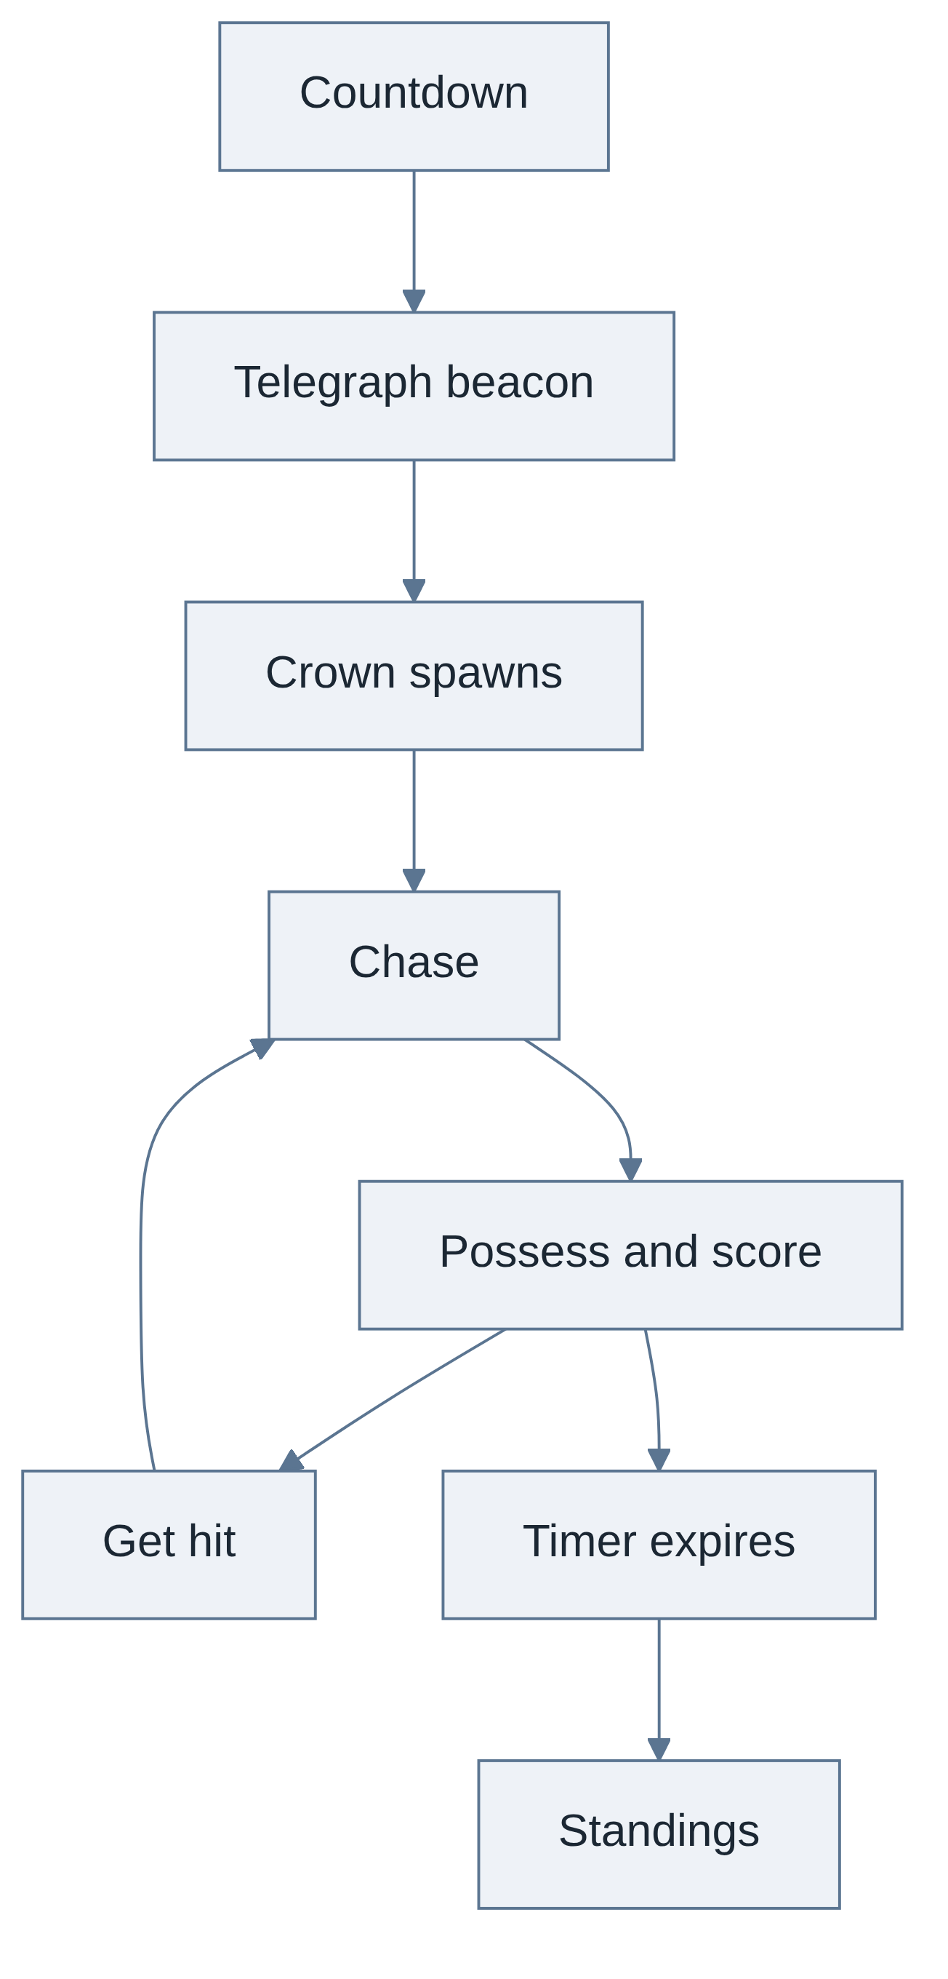

What Glowtag adds to the Foundation
Everything below is Layer H. Nothing here changes a foundation module.
Addition | Summary | Detail
The Crown | One networked object with a holder | FD-02
Spawn selector | Asymmetry rule over authored candidate points | FD-02
Possession and scoring | Flat rate while held, banked per tick | FD-01
Steal rule | Any classified contact against the holder transfers it | FD-03
Possession lockout | Reuses contact_immunity_ticks rather than adding a number | FD-03
Power-ups | Generic crates, one carried, five items | FD-04
HUD | The foundation ships none. All of it is ours | FD-01, FD-02, FD-04
Arena authoring | Track Data is not being built, so Glowtag authors its own anchors and bounds | FD-06
Bots | The lobby supplies a count only. The behaviour is ours | FD-07

Foundation overrides
Glowtag starts from Profile_Arena and overrides sparsely, per the Handling Profiles authoring rules.
Field | Arena default | Glowtag | Why
reserve_gain_rate | Near zero | Platform standard, as Race | Drifting grants boosts in Glowtag. Boost is not just speed — boost_bump_multiplier is 1.6×, so a boosting robot hits harder, which makes drift the primary earned steal tool rather than a pickup
window_ticks, stage thresholds | Platform default | Unchanged | Drift timing stays identical across every game on the platform
Everything else | Arena preset | Unchanged | High rotation authority, lower top speed, high mass, low inertia, short spin-out are all already what this mode wants

A note on charge stages in a small arena. Stage 3 needs roughly a three-second drift. An arena that size rarely offers one, so players will reach stage 1 often, stage 2 sometimes and stage 3 almost never. That is a good outcome and needs no extra tuning — the arena limits boost strength by its own geometry rather than by a number we picked.

Mechanics summary
Mechanic | One-line rule | Detail
Crown spawn | Random authored point, never equidistant between the two nearest players, telegraphed before it appears | FD-02
Possession | Held until stolen. Never dropped voluntarily | FD-02
Scoring | Flat rate per second while holding, banked instantly. No multipliers of any kind | FD-01
Stealing | Any classified contact against the holder. Mutual contact with no clear aggressor does not steal | FD-03
Slam | A slam also spins the loser out for the Arena preset's 0.75 s | FD-03
Possession lockout | The new holder receives contact_immunity_ticks of immunity. The Crown cannot move again inside it | FD-03
Boost | Earned by drifting, per the foundation. Also grantable by a power-up | FD-04
Power-ups | Generic crates. One carried, revealed on pickup, activated manually on a new sixth input | FD-04

UI overview
The foundation ships no HUD and communicates speed and boost state through the camera and the robot itself. Glowtag adds nothing that duplicates those — no speed meter, no charge meter.
Anchor | Element | Detail
Top centre | Round timer | FD-01
Top left | Scoreboard, with delta to leader | FD-01
Top right | Possession banner and streak timer | FD-02
Bottom centre | Power-up slot | FD-04
Bottom left | Event feed | FD-04
Screen edges | Off-screen Crown arrow, or rear-threat markers while holding | FD-02
World | Name tag above every robot | FD-02
Centre, transient | Countdown, steal banner, crate reveal | FD-01, FD-03, FD-04

Not shipping: minimap, power-up inventory, speed or charge meters, any visible sign of catch-up weighting.

Audio overview
A minimal set, buildable from a library.
Cue | Purpose | Detail
Crown hum | Continuous 3D loop — you hear the holder before you see them | FD-02
Streak pitch | Hum rises with the current possession streak. Lobby-wide tension, no numbers | FD-02
Steal stinger | On transfer, paired with hit-stop | FD-03
Blocked thud | A hit that lands but does not steal | FD-03
Score tick | Soft pulse, holder's client only | FD-01
Round audio | Countdown, final ten seconds, end horn | FD-01
Power-up | Crate break, reveal, activation, expiry | FD-04

Contact, boost, drift and spin-out audio all come from the foundation and are not respecified here.

Content checklist
Scoped against one concept artist and one 3D generalist, with no animator — nothing below needs a rig.
Item | Count | Note
Arena | 1 | Closed bounds. Authored Crown spawn candidates, crate points and start anchors. See FD-06
Data Crown | 2 meshes | Glyph cube and open ring cage. Emissive material, code-driven rotation and orbit. No rig
Item crate | 1 mesh | Generic. The player does not know what is inside until it breaks
Power-up icons | 5 | Overdrive, Grapple Field, Damper Field, Oil Slick, Repulse Pulse
VFX | ~8 | Emissive crown, ground trail, telegraph beacon, steal flash, blocked hit, Damper ring, crate break, repulse shockwave
SFX | ~12 | Per the audio table
UI screens | 2 | In-match HUD, round standings with superlatives
Player identity | — | Already exists. Robots are chosen and customised in the launcher, and player lists use persistent account names
Bots | 0 new assets | Bots drive roster robots through the player input pipeline. No new art and no new movement code — see FD-07

On daylight legibility. The Crown is emissive, but emissive alone does not read in daylight. It also needs a hard silhouette, saturation against a desaturated arena palette, and motion. That makes the arena's colour palette a constraint on the environment artist, recorded in FD-06.

Feature documents
Doc | Covers
FD-01 | Round structure, scoring, timer and scoreboard UI, standings
FD-02 | Crown spawn rule, the Crown object, possession feedback, possession UI
FD-03 | Contact and stealing, spin-out, steal feedback
FD-04 | Power-ups, crates, distribution, power-up UI
FD-05 | Glowtag's networking additions only
FD-06 | Arena authoring requirements
FD-07 | Bot behaviour

Open decisions
- Does a steal fire on any contact? Shipping as any contact for the first playtest. Alternatives are bump-or-above and slam-only — FD-03
- Overdrive strength — provisionally stage 2 equivalent, so a power-up never beats a perfectly executed chain — FD-04
- Repulse Pulse roll weight — deliberately rare, exact weight unset until playtest — FD-04
- A sixth input for power-up activation is a foundation change. Approved by design; needs the foundation team's sign-off — FD-04
- Manual respawn disabled in Glowtag — a closed arena has nothing to escape, and it would be a possession exploit. Needs the foundation team's nod — FD-03
- Holder speed penalty — not shipping. Recorded as a post-playtest lever, now known to be free via a transient modifier — FD-01
- Field size is now fixed at `MaxPartySize`, because bots fill every empty slot. Six was chosen when partial fields were possible; four is the lobby's own default. Re-rule before the arena blockout — FD-07

Dependencies and known gaps
- Track Data is not being built. Collision depends on it for a drivable volume and respawn anchors, and surfaces depend on its tagging pipeline. Glowtag absorbs all of that for its one arena — see FD-06.
- Networking rulings N1 to N9 and D1 are open, in Matchmaking & Lobby System v0.4. Glowtag has a stake in N1 and N2 — see FD-05.
- Oil Slick requires the Oil surface tag to be authorable on the arena without the Track Data pipeline. See FD-06.

All numbers are provisional. Every value quoted from a foundation document is repeated for convenience only; that document is the source of truth.

